Конспект занятия по развитию функциональной грамотности школьников
на уроке английского языка в 6 классе
по теме «Спортивные соревнования».

Учитель: Шляков Я.А., учитель иностранного языка МАОУ гимназии № 49 города Тюмени
Цель: формирование навыков свободного общения и практического применения на иностранном языке.
Задачи:
1. стимулировать речемыслительную активность учащихся,
2. создать ситуативность обучения, смоделировать учебную ситуацию, которая спровоцирует учащихся на спонтанную речь.
3. развивать способность критически рассматривать с различных точек зрения проблемы глобального характера и межкультурного взаимодействия;
4. осознавать, как культурные, религиозные, политические, расовые и иные различия могут оказывать влияние на восприятие, суждения и взгляды людей;
5. вступать в открытое, уважительное и эффективное взаимодействие с другими людьми на основе разделяемого всеми уважения к человеческому достоинству.

- Look at Kim’s school timetable and name the subjects she has on Monday, Wednesday, Thursday. What time does each lesson start and finish?
Example: The first lesson on Monday is English. It starts at 9 a.m. and it finishes at half past ten.
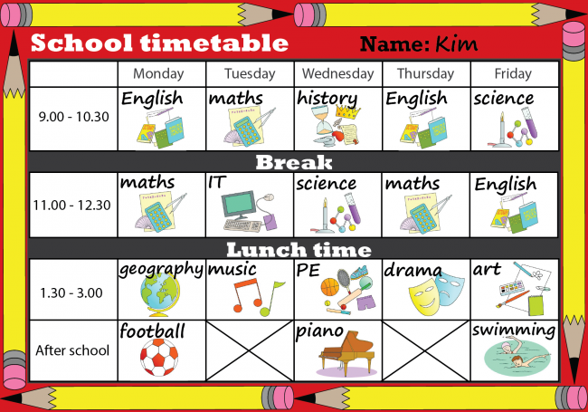

- You are in a restaurant. Look at the menu and count how much money do you need to order:
- House Baked Roll, soda water, Blackberry pie
- Twice Baked Beans, Fresh juice, Tiramisu
- Sweet Potato Fries, Organic Tea, Crème Caramel
- French Fries with Aioli, Flavoured milk, Cheesecake with Berries
- Chipotle mashed potatoes, Bottled mineral water, Red velvet cake
- Pesto pastasalad, Premium loose-Leaf Tea, Tiramisu.
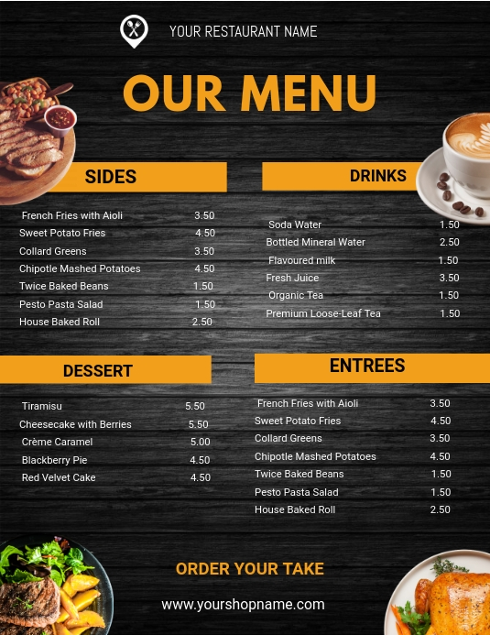

- Read the text and do the tasks below.
Popular sports in Great Britain.
People all over the world are fond of sports and games. Sports keep people united; make everyone healthy and strong; and bring a lot of positive emotions. Would you like to know what kinds of sports in Great Britain bring the British the joys mentioned above?

According to the recent National Sports Quiz results, the British consider the following kinds of sports as popular: football, cricket, rugby, golf, and racket sports. Let's have a quick look at each of them. Football is the national sport in England and Scotland. It is an obsession for many British people. The English Barclays Premier League is generally seen as the best league in the world, while the Scottish Premier League is also very successful. People worldwide support famous English clubs like Manchester United, Liverpool, Arsenal and Chelsea.

Cricket is the main summer sport in the UK and is played at various levels from village standard up to the England national team. The England team plays home Test matches, one-day internationals and Twenty20 matches every summer and goes on tour every winter. The undoubted highlight is the Ashes — England against Australia — contested every two years.

British rugby union is currently booming. British clubs are highly successful in the Heineken Cup — otherwise known as the European Cup. The English Guinness Premiership and Celtic League are both highly competitive and watched by sell-out crowds every week. The Rugby World Cup, which takes place every four years and was won by South Africa in 2007the biggest event in the rugby calendar. Rugby league is mainly played in the north of England, although the Super League includes a team based in Perpignan, France and London — the Harlequins. Rugby teams from England, Scotland and Ireland are going to participate in the Rugby League World Cup in 2008.

The UK is renowned as the home of golf and boasts hundreds of world-class courses. They include St Andrews, Wentworth, the Belfry and Carnoustie — four of the most famous course in the world. The British Open is held every July at different courses in the UK. It is the oldest and most famous of golf's four major championships.

Racket sports include tennis badminton and squash. Tennis, badminton and squash are all hugely popular sports in the UK. Tennis is probably the most widely-known, with tournaments such as Wimbledon and the Stella Artois Championships at Queen's Club and is a major part of every summer. British badminton players have been highly successful in recent years. The highlights are Gail Emms and Nathan Robertson, who won silver medals in the mixed doubles at the 2004 Olympic Games. The Yonex All England Open in Birmingham takes place in March and is the biggest tournament in the British calendar. Squash is another highly successful British sport, with players such as James Willstrop and Nick Matthew ranked among the top players in the world.
- Guess the kind of sport.
- ____________ has the best league in the world.
- ____________ is the most widely-known with tournaments and championships in summer.
- ____________ is a currently booming kind of sport.
- ____________ is the main summer sport in Britain.
- ____________ players won silver medals at the 2004 Olympic Games.
- Match the words with their equivalents.
Quiz | Лига
Tournament | Кубок
Championship | Участвовать
Crowd | Успешный
League | Соревнование
Cup | Турнир
Participate | Главный
Competition | Толпа
Successful | Опрос
Major | Чемпионат

С) Read the sentences and say TRUE or FALSE. Correct the wrong sentences.
1) Football is the national sport in England and Wales.
2) British badminton players have been highly successful in recent years.
3) The Rugby World Cup takes place every three years.
4) The England cricket team plays home Test matches, one-day internationals and Twenty20 matches every summer but doesn’t go on tour every winter.
5) Rugby league is mainly played in the north of England.

